Dr. Lee Roberson — Man of God!

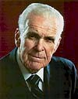

http://www.jesus-is-savior.com/images/gold_small_bar.gif

Dr. Lee Roberson (1909-2007) believed that the King James Bible is inspired. In his sermon, [***HAVE FAITH IN GOD***,](http://www.jesus-is-savior.com/Books,%20Tracts%20&%20Preaching/Printed%20Sermons/Dr%20Lee%20Roberson/have_faith_in_god.htm) he made the following statement concerning his text verse, **Mark 11:22, “And Jesus answering saith unto them, Have faith in God” ...**

*“Whether in sunshine or rain, it will help us to have these inspired words before us: HAVE FAITH IN GOD.”*

Pastor Roberson referred to the King James Bible as “these inspired words.” Amen. There are some preachers today who deny the inspiration of our precious King James Bible. It is apostasy. Thank God for Dr. Roberson's faith in the King James Bible as God's inspired, inerrant, infallible, impeccable and preserved Words of God.

A brief summary by J. R. Faulkner from "Get a Glimpse of the World's Largest Church" — 1973

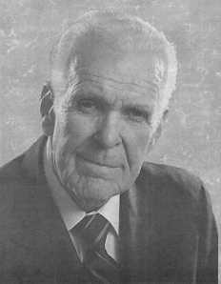Dr. Lee Roberson, loyal pastor of the *Highland Park Baptist Church*, and founder and president of Tennessee Temple Schools in Chattanooga, Tennessee, is world-renowned in religious circles. He was born in a two-room log cabin on November 24, 1909, and spent his first two years on a farm near English, Indiana, a small town in the southern part of the state. In 1911, his parents, Mr. And Mrs. Charles E. Roberson, took him to a farm near Louisville, Kentucky, where his father farmed, worked on streetcars, and built homes to make a living. At the age of fourteen, he was led to the Lord by his faithful Sunday School teacher, Mrs. Daisy Hawes, and joined the Cedar Creek Baptist Church outside of Louisville.

After spending two years at the Louisville Male High School, where he received a diploma in public accounting when he was fourteen years old, Dr. Roberson then attended the Fern Creek High School and was graduated after four years. While a student, he played football with the high school team.

Brother Roberson entered Old Bethel College in Russellville, Kentucky in 1926, and finished the first year. There he worked at various jobs from washing dishes to scrubbing floors to pay his way. From Old Bethel College, he went to the University of Louisville to complete his college work with a major in history. He also completed his work for a degree at the Southern Baptist Theological Seminary in Louisville. At the age of nineteen, he was called to a church in Jeffersontown, Kentucky, which he did not accept.

In his early years, Dr. Roberson was well known as a singer. Having studied at the Cincinnati Conservatory of Music and with the well-known teacher, John Samples, of Chicago, his services as a vocalist were in great demand. He served as a soloist on the staff of radio station WHAS of Louisville, Kentucky, and WSM out of Nashville, Tennessee. Doors were opening in the field of secular music. Dr. Roberson could have signed a contract with a certain man in the city of Nashville that, no doubt, would have led him to the top in music. However, he felt that this was not the thing the Lord wanted for him; so he refused to sign the contract.

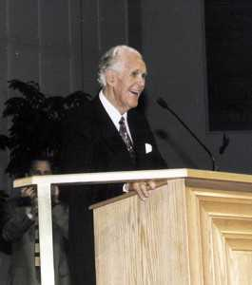The first church that Brother Roberson served as pastor was in Germantown, Tennessee, while he was going to college. In 1932, he was called to be pastor of the Temple Baptist Church in Green Brier, Tennessee. It was there that he discovered the truth of the second coming of Christ. After three years with the Green Brier Church, where the Lord wonderfully blessed, Dr. Roberson entered full-time evangelistic work in 1935. He served as evangelist of the Birmingham Baptist Association; and within two years, he conducted some fifty revivals in the Birmingham area.

It was while he was in Birmingham that he met Miss Caroline Allen, who, on October 9, 1937, became Mrs. Lee Roberson.

On the first Sunday in November 1937, Dr. Roberson became pastor of the First Baptist Church in Fairfield, Alabama.

In 1939, Brother Roberson was asked to be the state evangelist for Alabama. He felt this was not the Lord's will for him at the time, so the offer was not accepted.

On May 2, 1941, Lee Anne, the Roberson's oldest child, was born.

After five years with the Fairfield church, Dr. Roberson was called to the Highland Park Baptist Church in Chattanooga, Tennessee, in November of 1942. Brother Roberson, our pastor, is a man of God at home as well as at church. He has set an example of faithfulness and devotion to his family and to his convictions before his church and to the entire world. At home, he has sought to teach his children in the fear and admonition of the Lord around a daily family altar, which has reflected itself in the lives of the children.

Dr. Roberson's devotion to duty and to his convictions has laid upon him a demanding schedule that has caused him, throughout his life, to get up early and to burn the midnight oil in prayer and study of the Word of God and the writings of others that he might maintain his burden to reach as many souls for Christ as he can, by every possible means. New sermons are constantly pouring from his soul and new books from his pen.

Whether he be speaking from the pulpit of the Highland Park Baptist Church, the chapel platform of Tennessee Temple Schools, to his Men's Bible Class, or at one of many other special services, his messages are always fresh, fervent, and filled with the power of God. In speaking of him, someone has said, "He is truly the Spurgeon of our times."

Dr. Roberson's daily schedule begins with Bible study and prayer at 6:30 in the morning, followed by breakfast and devotions with his family, an soul-long broadcast beginning at 8:30 a.m., and a chapel service at Tennessee Temple Schools at 10:00. His morning hours are also filled with private conferences with church people and students of Tennessee Temple Schools. His daily visitation program takes him into the numerous hospitals of the city as well as homes of the church members.

We praise the Lord for the way in which He has blessed Dr. Roberson's ministry here at the Highland Park Baptist Church.

Pastor Roberson's favorite Scripture...

*"And we know that all things work together for good to them that love God, to them who are the called according to his purpose." —Romans 8:28*

**A Brief Biographical Review of Dr. Lee Roberson**

**From the** [**Sword Of The Lord**](http://www.swordofthelord.com/onlinesermons/LeeRobersonInGlory.htm) **by Brother Marlon W. Smith**

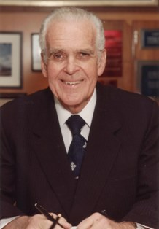Dr. Lee Roberson, pastor of Highland Park Baptist Church and founder of Tennessee Temple Schools died Sunday, April 29, 2007. He was 97.

Dr. Roberson was respected and held in highest esteem as a dynamic leader and a Christian statesman by multiplied thousands of Christians around the world. His reputation was that of an uncompromising stalwart whose consistent message lodged deep in the hearts of those who listened.

The heartbeat of his message could be summed up by his life verse, Romans 8:28, “And we know that all things work together for good to them that love God, to them who are the called according to his purpose.”

His legacy as a mighty man of God began in 1942 when he was called to be the pastor of Highland Park Baptist Church in Chattanooga, TN. For 40 years and 6 months (1942-1983), Dr. Roberson invested himself wholly in the ministry of the church, the city of Chattanooga and Hamilton County. He was loved as pastor, preacher, confidant and friend by those with whom he came in contact. During his tenure as pastor, more than 61,000 people professed faith in Jesus and followed Him in believer’s Baptism.

In 1946 he founded Tennessee Temple Schools which has trained thousands of pastors, missionaries and Christian workers now serving in churches and ministries worldwide.

Dr. Roberson became well known nationally and internationally as a vibrant and articulate conference speaker. He was one of the founding members of the Southwide Baptist Fellowship and was a regular speaker for many of the National Sword of the Lord Conferences. In his later years, as an evangelist, he preached in thousands of churches across America.

Having been saved at age 14, Dr. Roberson attended Bethel College in Russellville, KY, and went on to the University of Louisville where he graduated with a major in history. He also attended Southern Baptist Theological Seminary in Louisville.

His early years of ministry began in 1932 with a pastorate in Germantown, TN in spite of the urging of his teachers at the Cincinnati Conservatory of Music to pursue a career with the opera. Other pastorates include Greenbrier Baptist Church, Greenbrier, TN, and First Baptist Church, Fairfield, AL.

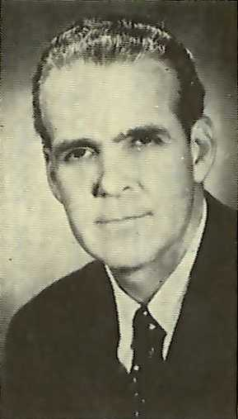Later he became an evangelist with the Birmingham Baptist Association in Birmingham, AL. While there he met and married Miss Caroline Allen in 1937. She preceded him in death on June 26, 2005.

Dr. and Mrs. Roberson had four children, LeeAnne, John, Joy & June. Their baby, Joy, for whom Camp Joy is named, died in 1946 at the age of two months.

Even to those who were not acquainted with Dr. Roberson, his presence commanded immediate respect. His classic attire, a dark blue, double-breasted suit, starkly contrasted by his snowy white hair, became his trademark.

Dr. Roberson became well known not only by his service to Highland Park Baptist Church and his popularity as a conference speaker and evangelist but also by his proclamations from the pulpit. Some of his best known admonitions to audiences were, “Have faith in God,” “Everything rises or falls on leadership” and “Just keep going down the line.”

Dr. Roberson’s reputation as pastor, preacher, educator and evangelist will not soon be forgotten. For more than 65 years, he was a key leader and one of the most influential preachers in fundamentalism.