Harry A. Ironside — Man of God!  
**(1876 - 1951)**

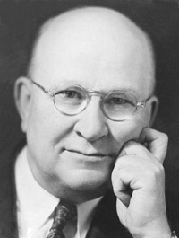*"Great truths that are stumbling blocks to the natural man are nevertheless the very foundations upon which the confidence of the spiritual man is built."*  
  
Few preachers had more varied ministries than this man. He was a captain in the *Salvation Army*, an itinerant preacher with the Plymouth Brethren, pastor of the renowned Moody Memorial Church in Chicago, and conducted Bible conferences throughout the world. Sandwiched between those major ministries, Ironside preached the Gospel on street corners, in missions, in taverns, on Indian reservations, etc.   
  
Never formally ordained and with no experience whatever as a pastor, Ironside took over the 4,000-seat Moody Memorial Church in Chicago and often filled it to capacity for 18 1/2 years. A seminary president once said of him, "He has the most unique ministry of any man living." Although he had little formal education, his tremendous mental capacity and photographic memory caused him to be called the "Archbishop of Fundamentalism."   
  
Preaching—warm, soul-saving preaching—was his forte. Special speakers in his great church often meant nothing; the crowds came when he was there. He traveled constantly at his prime, he averaged 40 weeks in the year on the road—always returning to Moody Memorial for Sunday services.   
  
His pen moved, too; he contributed regularly to various religious periodicals and journals in addition to publishing 80 books and pamphlets. His writings included addresses or commentaries on the entire New Testament, all of the prophetic books of the Old Testament, and a great many volumes on specific Bible themes and subjects.   
  
In 1951, Dr. Ironside died in Cambridge, New Zealand, and was buried there at his own request.

SOURCE: [Harry A. Ironside](http://www.swordofthelord.com/biographies/IronsideHarry.htm)