How We Understand Bible Prophecy...

THE RAPTURE EXAMINED...
by Dr. Andrew Corbett, Pastor of Legana Christian Church, National President of ICI Theological College Australia, Lecturer in Hermeneutics for Tabor Theological College Tasmania, and author of The Most Embarrassing Book in The Bible eBook
For years I was taught that the coming of Christ was to be in two stages: He would come for the Church, then He would later come with the Church. The first stage of this coming was called the rapture. I grew up in a church where we saw evangelistic films reinforcing this teaching and lately, the Left Behind series of books and films has continued to popularise this view as well. But now many Christians are asking some big questions about the rapture. This led me to investigate it for myself...

THE ORIGINS OF THE RAPTURE
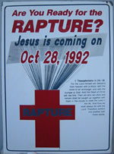
The Reformers of the sixteenth century saw sharp parallels between the apparent evils of an apostate religious group, as described in the Book of Revelation, and the Church of Rome. This opinion was so strong among the Reformers that they went as far as declaring that the Pope was the Anti-Christ, and the Roman Church was the Harlot of Babylon. One only needs to read the Westminster Confession of Faith which plainly states this belief.
Many believe that this attack on the Roman Catholic Church, known as Historicism, was strategically counted by a Jesuit, Francisco Ribera (1537 - 1591). He deflected some of this attack by developing the Futurist eschatological system. He published a book in 1591, in which he claimed that the Anti-Christ, the Fall of Babylon, and the destruction of a rebuilt temple in Jerusalem would all take place in the final seven years before the commencement of the millennium. Out of the seeds of Futurism grew the teaching of Edward Irving.

Edward Irving (1792-1834) was minister of the Church of Scotland. He was also influenced by the writings of another Jesuit Priest, Emmanuel Lacunza (who used the pseudonym Juan Josafat Ben-Ezra) who wrote a book, "The Coming of the Messiah in Glory and Majesty". Irving translated this Spanish book into English and added a 203 page Preface.
When the Lord shall have finished the taking of witness against the Gentiles... he will begin to prepare another ark of testimony... and to that end will turn his Holy Spirit unto his ancient people, the Jews, and bring them unto those days of refreshing... This outpouring of the Spirit is known in Scripture by ‘the latter rain’.
Published by L.B. Seeley & Sons, 1827, London, pp. 5-6.
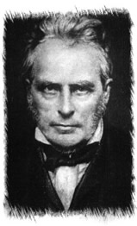
Irving planted the seeds of Dispensationalism which greatly influenced two other men. The first was John Nelson Darby (1800-1882), an Anglican minister who left the Church of Ireland to commence the Plymouth Brethren. The other was Henry Drummond (1786-1860), a banker, who founded the Catholic Apostolic Church.
In 1831 both Edward Irving and John Nelson Darby began to postulate a two-staged return of Christ. Some believe that Irving was influenced by a young girl, Margaret McDonald, who apparently received this ‘revelation’ from the Lord of a “rapture” of the Church before a time of Great Tribulation at the end of the age.

Through a series of Prophetic Conferences in England and the United States, this view gained popularity. But its most accelerated acceptance came when Cyrus Scofield (1843 - 1921) published his Reference Bible which incorporated the essential elements of Dispensationalism (including a secret rapture of the Church) into its study notes. This was published in 1909. Other such Dispensational Study Bibles began to appear throughout the twentieth century, including Dakes Annotated Reference Bible which almost became the standard text for the growing number of Pentecostals throughout the United States of America and Australia.

Throughout the twentieth century the Rapture theory has been prolifically promoted by Hal Lindsay’s now discredited book, Late Great Planet Earth, and more recently by Tim LaHaye’s and Jerry Jenkins’ fictional Left Behind series.

WHAT IS THE RAPTURE?

John F. Walvoord is perhaps considered the most vocal and prolific advocate for the rapture throughout the twentieth century. In his book, The Rapture Question, he defines the rapture as-
The Scriptures predict that the church will be raptured, or “caught up” to heaven, at the coming of the Lord for them. The word raptureis from rapere, found in the expression “caught up” in the Latin translation of 1Thessalonians 4:17.
John F. Walvoord, “The Rapture Question”, Zondervan, Grand Rapids, 1979
Rapture advocates build their case almost entirely on First Thessalonians 4:17.
Then we who are alive and remain shall be caught up together with them in the clouds to meet the Lord in the air. And thus we shall always be with the Lord.
1Thessalonians 4:17
We introduced this commentary by establishing three logical principles for interpreting God’s Word. I would also like to point out to those who may object to the association of “logic” with God’s Word that the word logic is derived from the Greek word, logos, which is a title and name of Christ.
These principles include: Examining the context; Avoiding Contradiction; and Appreciating the original intention. Generally, even Dispensationalists easily accept these three Hermeneutical principles. But in order for their system to work, they also require the addition of two other invented “laws”. These include “the Law of First Mention”, and “the Law of Double Reference.” I have already examined these principles of interpretation espoused by Dispensationalist proponents in the previous Appendix, and shown them to be grossly faulty.
By employing the sound principles of interpretation to the First Thessalonians 4:17 passage we should see that this refers not to a rapture, but to the resurrection. We draw this conclusion from the context of the passage.
In verse 13 the passage is referring to those Christians who have already died, and Paul is pre-empting their resurrection.
But I do not want you to be ignorant, brethren, concerning those who have fallen asleep, lest you sorrow as others who have no hope.
1Thessalonians 4:13
In verse 14 the passage is linked to the resurrection of Christ.
For if we believe that Jesus died and rose again, even so God will bring with Him those who sleep in Jesus.
1Thessalonians 4:14
In verse 16 the expression most commonly used for resurrection, “rise”, is used -
For the Lord Himself will descend from heaven with a shout, with the voice of an archangel, and with the trumpet of God. And the dead in Christ will rise first.
1Thessalonians 4:16

Prior to the invention of the rapture doctrine, all published commentators interpreted this First Thessalonians passage as referring to the resurrection. For example, Matthew Henry’s commentary on this passage says –
They shall be raised up from the dead, and awakened out of their sleep, for God will bring them with him, v 14. They then are with God, and are better where they are than when they were here; and when God comes he will bring them with him. The doctrine of the resurrection and the second coming of Christ is a great antidote against the fear of death and inordinate sorrow for the death of our Christian friends…v.17. At, or immediately before, this rapture into the clouds, those who are alive will undergo a mighty change, which will be equivalent to dying…
Matthew Henry, 1721
Matthew Henry, along with nearly all other commentators prior to the invention of Dispensationalism, saw the obvious intention of this passage as referring to the resurrection of the dead at the final coming of Christ, not a secret rapture prior to the resurrection.
Applying the principle of Non-contradiction this First Thessalonians 4 passage compliments statements in First Corinthians 15.
in a moment, in the twinkling of an eye, at the last trumpet. For the trumpet will sound, and the dead will be raised incorruptible, and we shall be changed.
1Corinthians 15:52
The whole point to First Corinthians 15 is resurrection, not rapture.

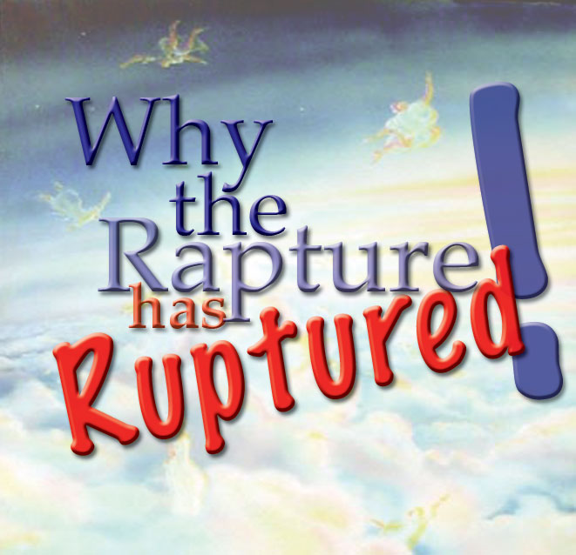
DOES SCRIPTURE TEACH IT?
No. Let’s examine some of the key Scriptures used to justify a rapture:
Matthew 24:40-41 "Then two men will be in the field: one will be taken and the other left. Two women will be grinding at the mill: one will be taken and the other left.”
- The context of this reference is clearly to the random killings perpetrated by the Romans and their siege of Jerusalem and Judea. Notice the entire passage of Matthew 24 pertains to the destruction of the Temple (vss 2-3). The Gospel of Matthew was written before the destruction of the Temple in 70AD which makes this particularly prophecy by Christ so amazing. If the Gospel of Matthew was written after 70AD there is no way the fulfilment of this prophecy would have been omitted by Matthew (it would be like writing the history of New York today and completely ignoring the events of 9-11). Some commentaries attempt to make this passage equate to the final eschaton or gathering God's people. But the passage pertains to the generation of Christ's audience (Matthew 24:34) and Christ has already warned His audience that when they see the events of Matthew 24 beginning to take place they (His followers) are to flee the city. Therefore, those left in the city when judgment on Jerusalem was to commence were not His people.
1Corinthians 15:52 “in a moment, in the twinkling of an eye, at the last trumpet. For the trumpet will sound, and the dead will be raised incorruptible, and we shall be changed.”
- The context of this reference is universally accepted as pertaining to the resurrection, not rapture.
1Thessalonians 4:13-18¶ But we do not want you to be uninformed, brothers, about those who are asleep, that you may not grieve as others do who have no hope. For since we believe that Jesus died and rose again, even so, through Jesus, God will bring with him those who have fallen asleep. For this we declare to you by a word from the Lord, that we who are alive, who are left until the coming of the Lord, will not precede those who have fallen asleep. For the Lord himself will descend from heaven with a cry of command, with the voice of an archangel, and with the sound of the trumpet of God. And the dead in Christ will rise first. Then we who are alive, who are left, will be caught up together with them in the clouds to meet the Lord in the air, and so we will always be with the Lord. Therefore encourage one another with these words."
- As with First Corinthians 15, this passage is about the Resurrection of the Righteous, not a secret Rapture disconnected from the Resurrection. Paul is responding to a question from the Thessalonians about those who had died in Christ and not participated in the expected resurrection of the righteous. He refers to these believers as having fallen asleep. This event is yet to happen. It is the Resurrection at the Return of Christ, not a Secret Rapture 7 years before the Return of Christ.
Revelation 4:1 After these things I looked, and behold, a door standing open in heaven. And the first voice which I heard was like a trumpet speaking with me, saying, "Come up here, and I will show you things which must take place after this."
- The context of this reference is essential to understanding the nature and perspective of the Book of Revelation. John received this Revelation from God and was able to see things from God’s perspective. This is not a reference to the rapture.
Revelation 12:5 She bore a male Child who was to rule all nations with a rod of iron. And her Child was caught up to God and His throne.
- The context of this reference is to the ascension of Christ, not the rapture of the Church.
Rapturists claim that there are Old Testament precedents for the rapture. They appeal to both Enoch and Elijah as examples of rapture.
By faith Enoch was taken away so that he did not see death, "and was not found, because God had taken him"; for before he was taken he had this testimony, that he pleased God.
Hebrews 11:5
We should apply the Hermeneutical principle of Non-Contradiction to this statement by Rapturists.
And as it is appointed for men to die once, but after this the judgment,
Hebrews 9:27
How do we reconcile these two seemingly contradictory verses? Are the claims of the Rapturists correct when they imply that Enoch levitated to Heaven? When the Scriptures declare that Enoch did not see/experience/taste death, does this mean that he did not have to go through a “dying” experience? Or, does it mean that he is physically in Heaven now and does not need to partake in the resurrection since he has kept his own body? It appears that there is a case to be made for saying that Enoch did not experience dying like all others, yet he still “died” in the sense that he was separated from his body (note James 2:26).
In either case, this is more a case of translation rather than rapture. The same applies to Elijah. Some see Noah’s Ark as a type of rapture. It would be more accurate to see Noah’s Ark as a picture of Christ instead.

WHAT THEN IS OUR HOPE?
looking for the blessed hope and glorious appearing of our great God and Saviour Jesus Christ,
Titus 2:13
Some Christians have linked their entire hope to a future return of Christ. A cursory examination of the topic of “hope” in the New Testament will readily show that hope is not just confined to the statement made in Titus 2:13. For example, we have the hope of the resurrection (Acts 23:6) and, the hope of spending eternity with God (Col. 1:5; Titus 3:7). Indeed the believers who lived before 70AD certainly did have reason to look forward to Christ’s appearing when He would come to close the amnesty of the Old Covenant and establish His kingdom. At the judgment of Jerusalem in 70AD, Revelation prophetically described as -
Then the seventh angel sounded: And there were loud voices in heaven, saying, "The kingdoms of this world have become the kingdoms of our Lord and of His Christ, and He shall reign forever and ever!"
Revelation 11:15
This seventh trumpet corresponds to the trumpet of Matthew 24:31 -
And He will send His angels with a great sound of a trumpet, and they will gather together His elect from the four winds, from one end of heaven to the other.
Matthew 24:31
The seventh trumpet announced the completion of God’s Old Covenant with Israel and the announcement that the Kingdom of Christ had begun (Rev. 11:15). Yet their remains a final trumpet, which we might call the “eighth”. Note the comparison between the seventh and the final (or perhaps the "eighth") trumpets-
7th TRUMPET | LAST TRUMPET
· A parousia of Christ | · The Final Parousia of Christ
· Jerusalem | · Earth
· Judgment on Judaism | · Final Judgment
· Fulfils Matthew 24 | · Fulfils Matthew 25; 1Thess. 4; 1Corinthians 15, Rev. 20:9ff
· Ends the Old Covenant Age (note Heb. 8:13) | · End of the Age
· Proceeds from preaching the Gospel to Jews first throughout the oichoumene (Empire) | · Proceeds from the making of disciples of all the nations (Matthew 28:18-20)
· Suffering, misery and death | · Suffering, misery and death done away with (Rev. 21:3-4)
· Satan is bound | · Satan is damned
· The beginning of Christ’s Kingdom | · The culmination of Christ’s Kingdom (Eph. 1:10; 1Cor. 15:24)
Our hope is grounded in what Christ has done for us by granting us salvation encompassing, forgiveness, justification, and glorification. We therefore do not die without hope. Much of the basis for this is grounded in Christ’s resurrection and its implication for our resurrection.
The Gospel is not a message that warns people of a Secret Rapture! This kind of Rapture has nothing to do with the Gospel! By exposing the modern teaching of a Secret Rapture as a fairly recent invention in pop-theology, it is my hope that Christians disburse from the Rapture bus-stop and get back into the main game of life. Rather than waiting for Jesus to rescue them from this naughty world, believers should strive to be salt and light on Christ's behalf to a world that would just love to see someone passion and genuine about what they believe in: Jesus Christ, Saviour and Forgiver to all those who are reconciled to God. We know that life will always have its tribulations. The Church will never rule the world and bring in some kind of utopian bliss, but the those in the Church can be better prepared to handle life's difficulties if they are not waiting for some kind of false hope such as a Secret Rescue Rapture.
Listen to Matthew 24 Explained MP3
Andrew Corbett
I have written a fuller explanation of the book of Revelation in my eBook- THE MOST EMBARRASSING BOOK IN THE BIBLE (click here to read a preview).

Amen.
© 2009, EGZAKT FOUNDATION TRUST , Tasmania, Australia | PO Box 1143 Legana, Tas., Australia 7277 | eMail

